Lab Assignment 3

Smit Shah (201701009), Kartikeya Gokhale (201701175)

February 19th, 2019

QUESTION – 1

Computationally investigate the motion of a pendulum and a spring-mass system as discussed in the class (without any damping). Draw phase plots to explain your observations.

ASSUMPTIONS:

1. Air drag is neglected.
2. Effect of air density is neglected.
3. The displacement is very small.

INITIALIZATIONS:

1. Initial Theta = 3.14/18
2. g = Gravitational Acceleration = 9.8
3. Length l = 1
4. Initial angular velocity init_w = 0
5. Mass of body for spring = 3
6. Spring constant k = 10

ANALYTICAL SOLUTION:

$$dw/dt = -g*θ/l$$

$$dθ/dt = w$$

COMPUTATIONAL MODEL:

The matrix d1dt has the values: d1dt(1) = angular displacement = theta and d1dt(2) = angular velocity = w. We used @ode45 to calculate the differential equations.

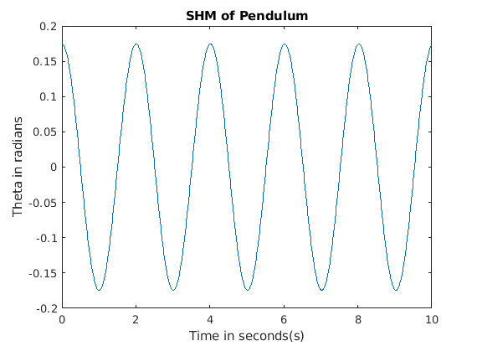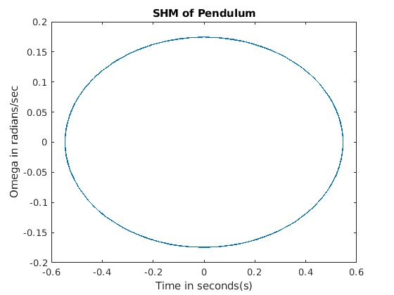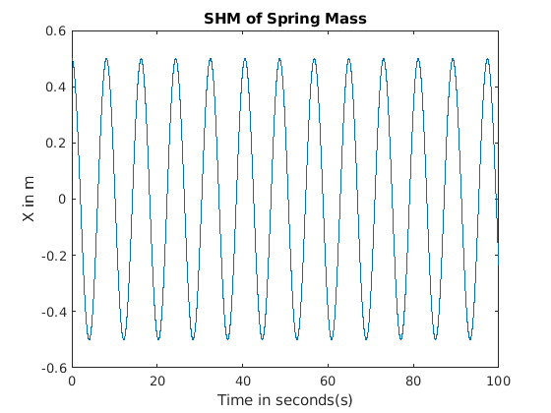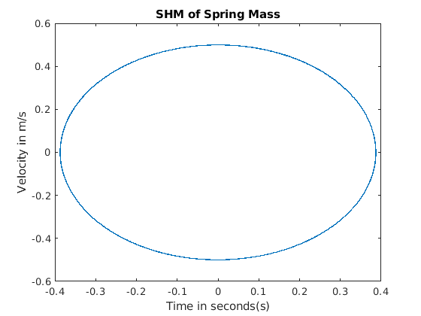

OBSERVATIONS:

1. The phase circle is complete in both the graphs, i.e. the motion is periodic.
2. Both the plots have a sinusoidal wave-form for displacement and velocity (angular displacement and angular velocity for the Pendulum) .

QUESTION – 2

1. Investigate (computationally) the cannon-shell trajectories ignoring both air drag and the effect of air density. Compare your result with exact solutions. Acceleration due to gravity depends on altitude; include this effect in your computational model by making some rational assumption

ASSUMPTIONS:

1. Variation in gravitational acceleration with height.
2. Air drag is neglected
3. Effect of air density is neglected
4. Target at same height as that of canon

INITIALIZATIONS:

1. Initial angle θ = 30◦
2. v_ini = 10 m/s
3. Radius of earth 6400km
4. Acceleration due to gravity go = 9.8 m/s2

ANALYTICAL SOLUTION:

Acceleration due to gravity changes with height,

$$g=g_{0}(1-2h/R)$$

Velocity in x direction

$$v_{x}=v_{0}cos⁡(θ)$$

Velocity in y direction

$$v_{y}=v_{0}sin⁡(θ)$$

Acceleration in x

$$a_{x}=\frac{d^{2}x}{dt^{2}}=0$$

Acceleration in y

$$a_{y}=\frac{d^{2}y}{dt^{2}}= -g$$

Displacement in x

$$x=v_{x}*t$$

Displacement in y

$$x_{y}=v_{y}*t+\frac{1}{2}*g*t^{2}$$

COMPUTATIONAL MODEL:

The matrix d0 has the values:

d0(1) has displacement in the x-direction and d0(2) has displacement in the y-direction. We used @ode45 to calculate the differential equations. The velocity along the x-direction remains constant, whereas the velocity along the y-direction changes. So, the acceleration along the x-direction is zero.

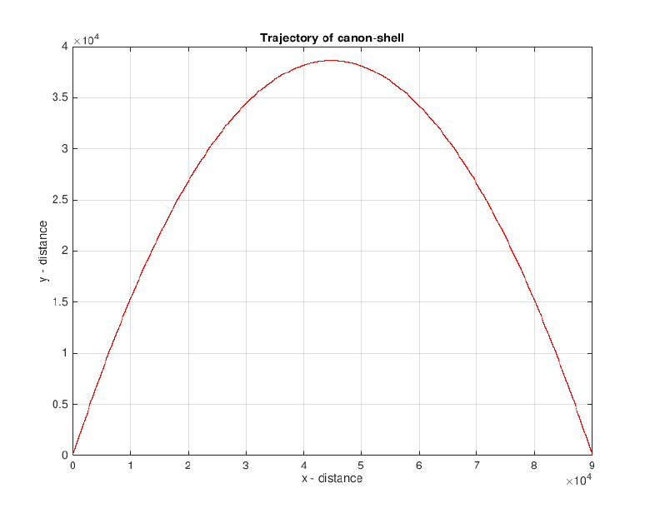

OBSERVATIONS:

1. The first observation that we make is that the velocity and the distance travelled by the object of mass m is independent of its mass whenever we neglect the effect of atmosphere.

2. The range travelled by the object will be maximum when the angle of projection is 45◦.

3. Since the acceleration changes with height, the velocity obtained by the body will decrease till it reaches the maximum height and then will start increasing till it reaches the maximum velocity.

(b)Investigate the trajectory of the canon shell including both air drag (proportional to square of velocity) and reduced air density at high altitudes. Perform your calculation for different firing angles; and determine the value of the angle that gives the maximum range.

$$F_{drag}= -bv^{2}$$

Density varies as follows

$$ρ= ρ_{0}e^{-\frac{y}{y_{0}}}$$

y is the altitude $y_{0}=1000m$

ASSUMPTIONS:

1. Gravitational acceleration is constant with height.

2. Drag force is proportional to v2

INITIALIZATIONS:

1. Initial angle, θ = 30◦
2. Initial velocity, v0 = 750 m/s
3. Radius of the Earth = 6400e3
4. Acceleration due to gravity = g0 = 9.8 m/s2
5. Velocity at any point of time $v=\sqrt{v_{x}^{2}+ v_{y}^{2}}$
6. Velocity in x direction $v_{x}=v_{0}cos⁡(θ)$
7. Velocity in y direction $v_{y}=v_{0}sin⁡(θ)$
8. Air drag constant = b
9. Fd air drag force = bv2
10. Change in atmospheric density $ρ= ρ_{0}e^{-\frac{y}{y_{0}}}$
11. Initial atmospheric density $ρ_{0}=1.225$

ANALYTICAL SOLUTION:

$$F_{dt}=\frac{ρ}{ρ_{0}}*F_{d}$$

$$\frac{b}{m} = 4e-5$$

Thus the acceleration in x

$$a_{x}= -\frac{b}{m}*e^{\frac{x}{x_{0}}}*v*v_{x}$$

Acceleration in y

$$a_{y}= -g-\frac{b}{m}*e^{\frac{x}{x_{0}}}*v*v_{y}$$

Displacement in x

$$x = v_{0}cos(θ)t$$

Displacement in y

$$y = v_{0}sin\left(θ\right)* t-\frac{1}{2}\left(a_{y}\right)*t^{2}$$

COMPUTATIONAL MODEL:

The matrix d0 has the values :

d0(1) has displacement in the x-direction and d0(2) has displacement in the y-direction. We used @ode45 to calculate the differential equations. The velocity along the x-direction remains constant, whereas the velocity along the y-direction changes. So, the acceleration along the x-direction is zero.

GRAPHS:

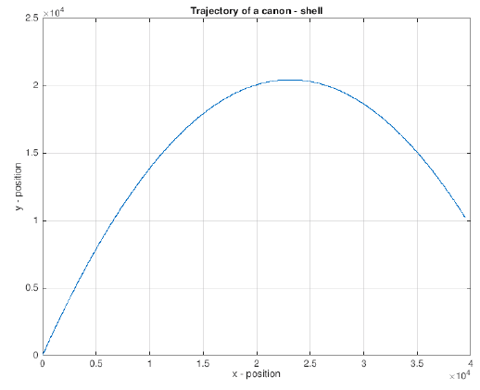

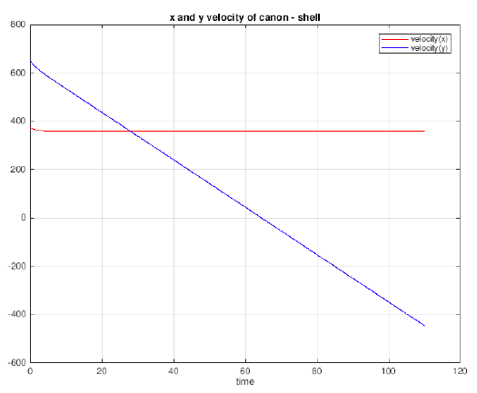

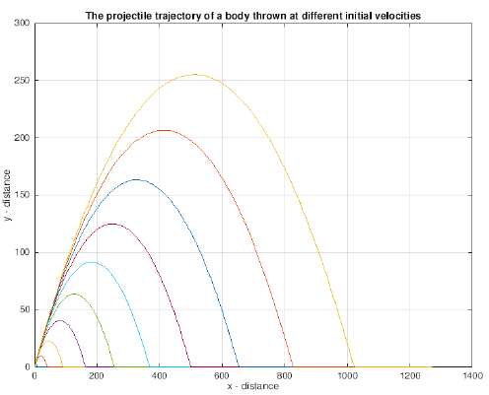

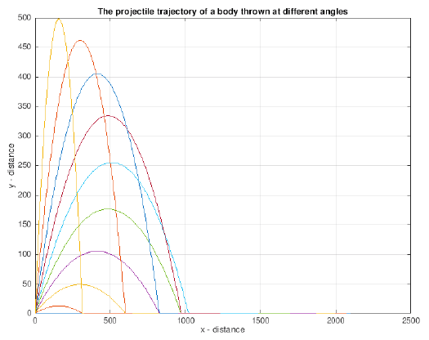

OBSERVATIONS:

The first observation that we make is that the velocity and the distance travelled by the object of mass m is dependent on its mass due to the presence of air drag force.

(c) Generalize the program so that it can deal with situations where the target is at a different altitude (higher or lower) than the canon. Investigate for both the cases. How the minimum firing velocity to hit a target varies as the altitude of the target varies.

ASSUMPTIONS:

1. No effect of air drag
2. Ignore effect of air density
3. Density of Air remains constant with height
4. Gravitational Acceleration changes with altitude, altitude is very small compared to radius of earth

INITIALIZATIONS:

1. ch = height of the cannon
2. h = height of the target
3. x = distance between the target and the cannon

SOLUTION:

$$v= \sqrt{\frac{gx^{2}}{2\cos^{2}{θ(xtanθ-h+ch)}}}$$

In this way the minimum velocity could be found given a height and distance of a cannon from the target for a firing angle.

GRAPHS:

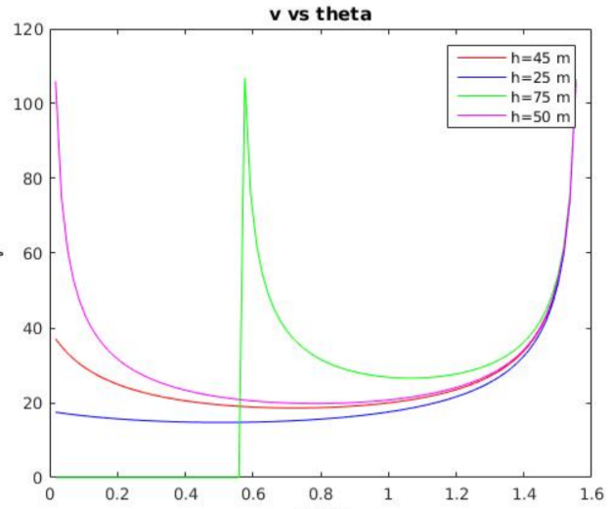

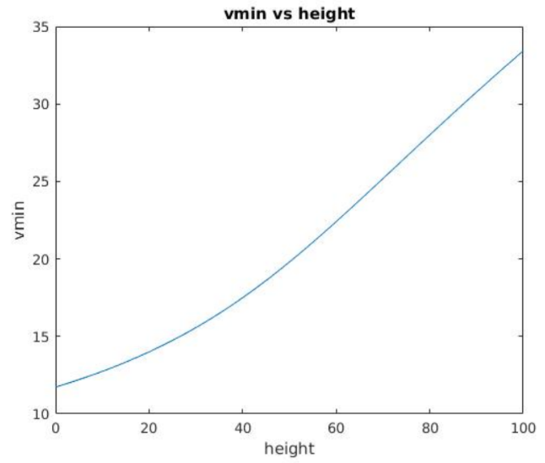

OBSERVATION:

For altitude greater than height of cannon; initially for very small an-

gles, the object can never reach the target.

Then there will be an angle, where you will need infinite velocity to

reach the target.

Now as you increase the angle the velocity required decreases and

reaches a minimum.

Beyond this point, if you increase the angle, velocity required again in-

creases.

For altitude less than height of cannon, object will reach the target

at angle 0. However, if you increase the angle, there will be a point

where minimum velocity is required. Beyond this, velocity increases.

QUESTION - 3

Bicycle problem:

(a) Rewrite the bicycle problem/code as discussed in the class. Investigate the effect of

rider’s power, mass and frontal area on the ultimate velocity.

Generally, for a rider in the middle of a group the effective frontal area is about 30% less than the rider at the front. How much less energy does a rider in the group expend than one at the front (assuming both moving at 12.5 m/s).

ASSUMPTIONS:

1. Constant power is provided to the bicycle by the cyclist.
2. The force acting on the bicycle is constant as the velocity is less.
3. The surface on which the bicycle is moving is friction-less.

INITIALIZATIONS :

1. Initial position, init_x = 0
2. Initial velocity, init_v = 10
3. Power = 400
4. Mass of the system(person + bicycle) = 60
5. Drag coefficient, c = 0.5
6. Acceleration, a = 0.25
7. Air density = 1.225

ANALYTICAL SOLUTION:

$$F = m*dv/dt$$

$$P = dE/dt$$

$$P = mv*dv/dt$$

Solving or v gives us,

$$v = {v_{init}}^{2} + 2Pt/m$$

But this is incorrect as the velocity keeps on increasing, we deal with this by subtracting a drag factor,

$$F_{drag}= -cρAv^{2}$$

For moderate velocity we have,

$$dv/dt = P/mv - CρAv^{2}$$

Reaching the terminal velocity, dv/dt = 0,

$$P/mv = (-1/2*ρ_{air}Av^{2}) / m$$

$$P = 1/2 * ρ_{air}Av^{3}$$

Therefore,power will be directly proportional to Frontal Area. So if the rider at the middle has effective frontal area 30% less than the rider at Front then Power expend by rider at the middle will be 30% less than the Power expended by rider at the front.

COMPUTATIONAL MODEL:

For computational analysis, we use matlab’s ode45 differential equation solver. Change in velocity with respect to time is calculated by solving differential equation where in the step size is taken as 0.1 with initial velocity of 10, frontal area = 0.33, Power = 400, mass = 60 and the time interval of simulation is 100.

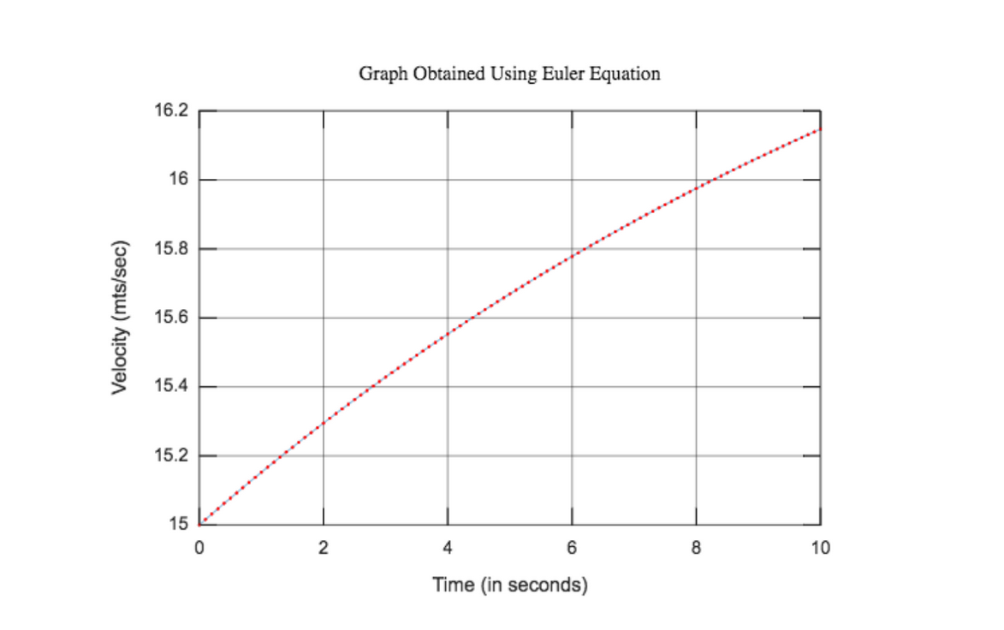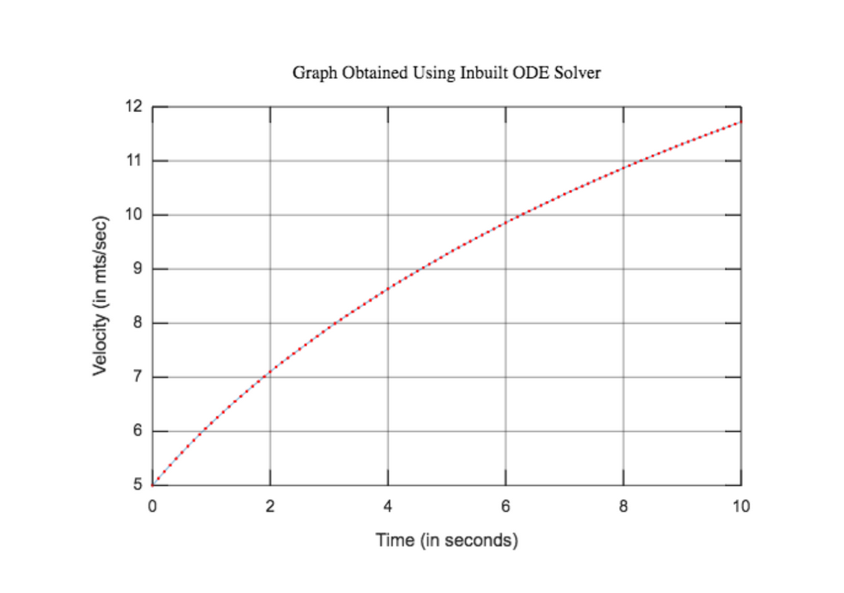

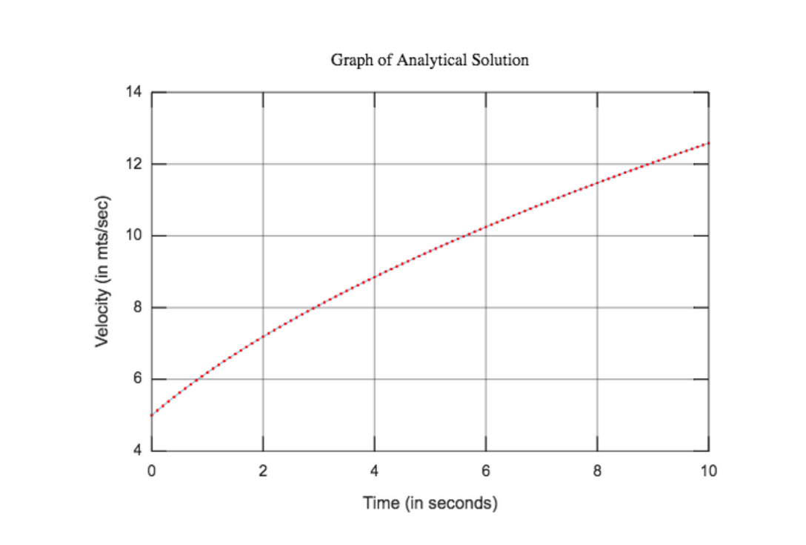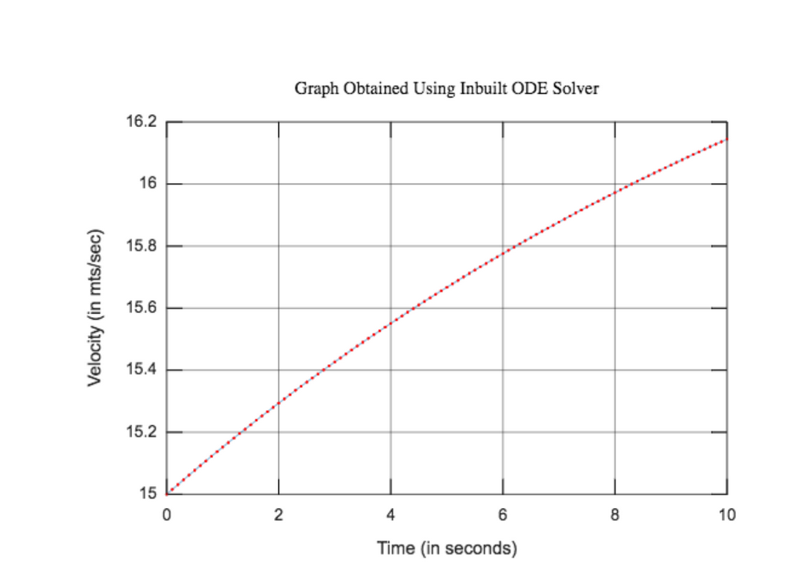

OBSERVATIONS :

1. Here if the initial velocity is greater than terminal velocity then the graph is decreasing as the v2 terms will dominate. So the ode solver is given initial velocity less than terminal velocity and Euler’s graph is given more velocity.

2. If you give a much higher initial velocity then drag will be even bigger as it depends on v2. So you will not be able to peddle and drag will overpower you and the velocity slowly decreases until a point when both cancels each other.

3. As we can see if we increase mass allowing all other variables be constant, terminal velocity is not changed by much, however, time required to attain terminal velocity is increased .

4. Investigation of the effect of rider’s power, mass and frontal area on the terminal velocity :

|  |  |
| --- | --- |
| Power | Terminal Velocity |
| 400 | 12.5719 |
| 200 | 9.9784 |
| 100 | 7.9234 |

As we can see that if we increase power, the terminal velocity increases.

|  |  |
| --- | --- |
| Mass | Terminal Velocity |
| 75 | 12.5719 |
| 100 | 12.5707 |
| 200 | 12.5145 |

As we can see, even if we increase mass, the terminal velocity does not change significantly.

|  |  |
| --- | --- |
| Frontal Area | Terminal Velocity |
| 0.2 | 14.8525 |
| 0.33 | 12.5719 |
| 0.75 | 9.5622 |

(b) Run your code (case (a) discussed during class) with initial v=0; observe the output and give possible explanation. Explain why it is important to give a non-zero initial velocity.

As shown, we formulated a formula of acceleration, in which there is a term where we divide acceleration with velocity. But if we take initial velocity as zero, then at time zero the acceleration becomes infinite so velocity will also jump directly to infinity.

We have taken power as constant (Power = Force * velocity) but if our assumption is true then at velocity equals to 0, the force becomes infinity, which is not possible. So we must have some positive initial velocity.

(c) As discussed in the class, we have assumed that the bicyclist maintains a constant power. What about the assumption when the bicycle has a very small velocity? (instantaneous power=product of force and velocity).

Here if we take initial velocity 0.001 m/s then according to equation dv/dt = P/mv = F/m . We have constant power hence to achieve such small velocity we need too large force which is not possible in real life situation.

(d) At low velocities it is more realistic to assume, that the rider is able to exert a constant force. That means for small “v” there is a constant force, which means eqn is dv/dt=F0/m.

ASSUMPTIONS: Same as question 3(a)

INITIALIZATIONS:

1. M = mass = 50
2. P = power = 100
3. A = Area = 0.33
4. Init_x = 0, init_v = 1, init_a = 0

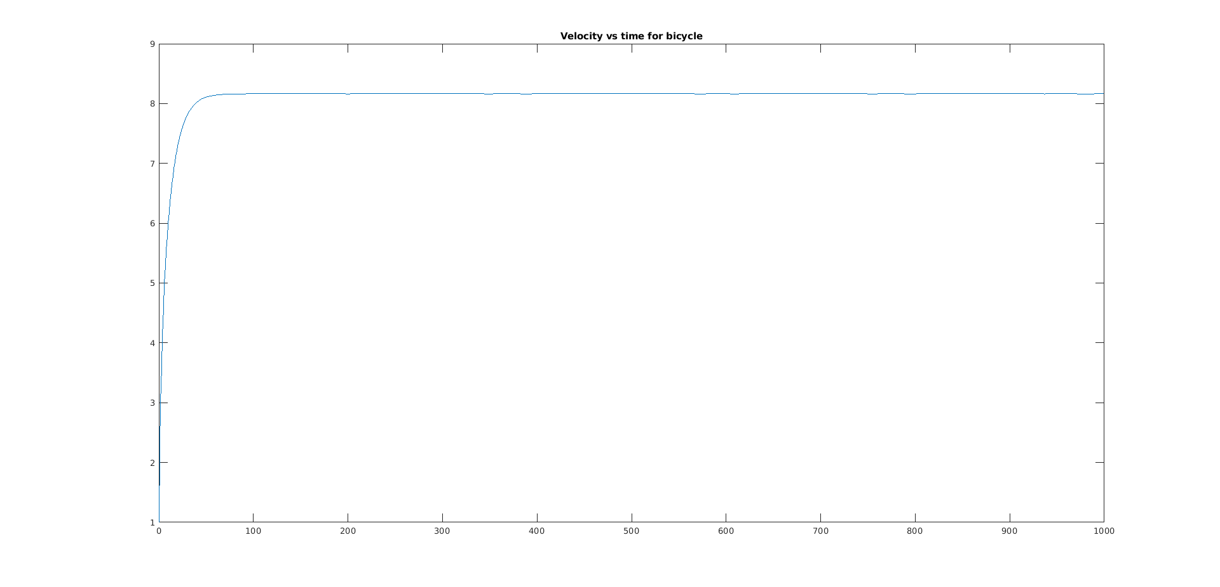

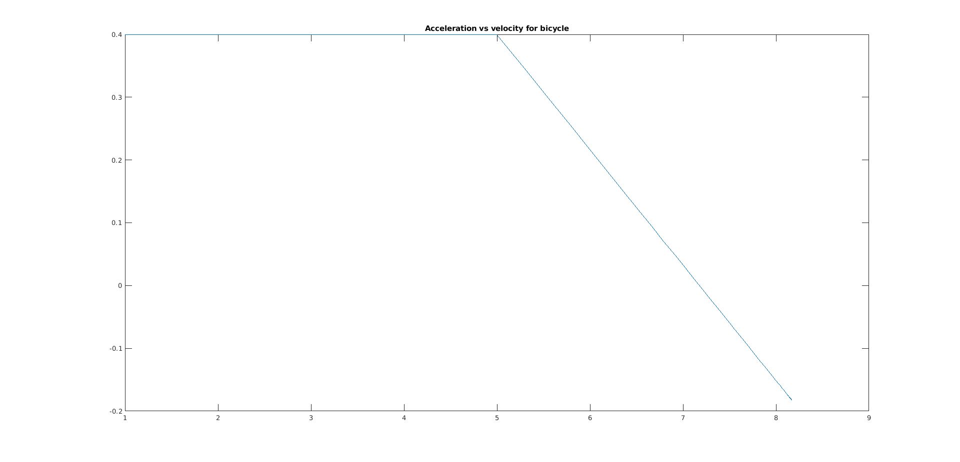

OBSERVATIONS:

1. Here, as seen from the graph, acceleration is constant for low velo. and decreases linearly with increase in velocity.
2. This scenario will also work for zero initial velocity and low initial velocities as force is considered constant during that time.